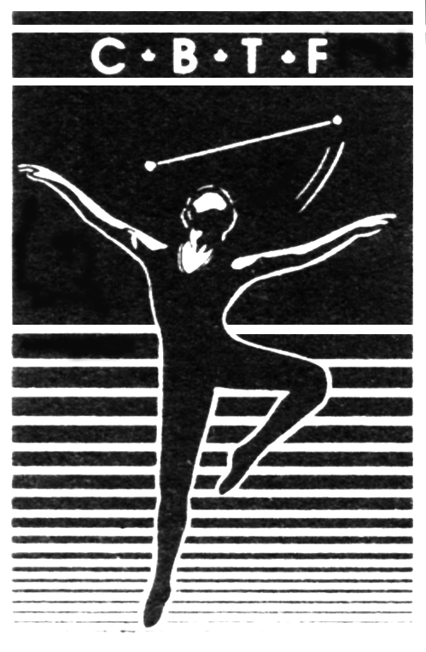
Canadian Baton Twirling Federation

La Fédération Canadienne de Baton Sportif

General Information

Preliminary CBTF Contingent Schedule - Subject to change - schedule will be confirmed after June 15, 2019

CBTF Contingent Schedule - Subject to change
Date
Thursday, August 1 | I Cup Contingent arrives in Limoges and checks in at contingent hotel  practice if possible – not mandatory to practice this day
Friday, August 2 | Practice day  Secret Pal starts today
Saturday, August 3 | Practice day  Canadian Contingent Welcome Reception(tentative)
Sunday, August 4 | Practice day  I Cup Opening Ceremony
Monday, August 5 | I Cup preliminary rounds
 | B & A solo, B & A 2 baton, B, A & Elite 3 baton, B, A & Elite artistic pair
Tuesday, August 6 | I Cup preliminary rounds  B, A & Elite artistic twirl, B & A team, artistic group
Wednesday, August 7 | Semi-final rounds:  B & A solo, B & A 2 baton, B, A & Elite 3 baton, B, A & Elite artistic pair  B, A & Elite artistic twirl,  Finals: B & A team, artistic group  Twirl Nations Clinic
Thursday, August 8 | All remaining I Cup finals  Awards & Closing ceremony
 | Final Secret Pal day
Friday, August 9 | Grand Prix opening ceremony  Duet preliminary round
Saturday, August 10 | Preliminary rounds:  Elite team, solo, 2 baton  Semi-final rounds:  Elite solo, 2 baton
Sunday, August 11 | Final rounds:  Duet, Elite 2 baton, solo, team  Grand Prix Award & Closing Ceremony

Notes:
- Schedule is subject to change
- Welcome Reception date tentative
- Practice schedule is tentative until confirmed by CBTF – late June
- Transportation to/from practice facilities will be by bus
- Transportation to/from the competition venue will be by bus

Venues
- Competition Site: Zénith Limoges Métropole. More information on the venue can be found on the website:
https://www.zenithlimoges.com/en/node/26526

The event organizers will not have wifi capacity at the venue. There will be vendors, and a food tent (outside). The athlete buffet will be approximately $20.00 CAD per meal. There are a few food options for spectators. It will be hot. Sunscreen is recommended. There is no air-conditioning in the venue. Change rooms will be in tents outside. There is space for car parking at the arena

- Contingent Hotel:

- We are still working to confirm the contingent hotels. Once again, the size of the contingent is very large and is causing difficulties. Our goal is to have hotels close together as we are too big to fit in one hotel. We have requested hotels near the train station. As soon as hotels are confirmed we will circulate further information as to the name and location of the hotels. We may be as spread out as four or five hotels.

Electric Transformer/Adaptor, Currency:
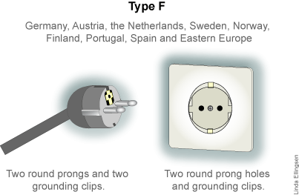
France uses the Europlug (Type C & F) for electricity, with two round prongs. So what kind of electric transformer or adapter do French travelers need for the 220 volts coming out of the electrical outlets? It's not too hard to find out what kind of plug or converter you need for electrical outlets in France. Most laptops will automatically work with 220 volts (check the back of your laptop for power input markings.) That means, you'll only need an adapter to change the shape of your power plug to fit into an outlet in France.
If you bring small appliances, you should double-check. The shape adapter may not be enough. While basically all personal electronics in recent years will accept both voltages, some older, smaller appliances don't work with the strong 220v current in Europe. Check if the label near the appliance's power cord shows 100-240v and 50-60 Hz. If it does not, you will need a "step-down transformer" (also called a converter). The converter will reduce the 220 volts from the outlet to provide just 110 volts for the appliance.
Tip: Don't bring any type of hair dryer or straightener to France - they are awfully hard to match up with a suitable converter due to astronomical power consumption. Just buy a cheap one locally.
FRANCE USES THE EURO. Well in advance, you should order Euro. Bank cards will likely not work in the Bankomat (ATM) machines in Limoges. There is no foreign currency exchange offices in Limoges. Credit cards and cash are accepted. You may wish to consider opening an HSBC account as you can only exchange currency with the banks there if you have an account with them.

2019 International Cup/Grand Prix Contingent Package
This package is designed for the International Cup/ Grand Prix athlete, coach, chaperone.

Note that Spectator Ticket Packages are being sold online directly to spectators. Please order your own tickets from the FFTSB website. There will not be reserved seating and CBTF will not be ordering the tickets for you. This is different than in past years.

Also note - breakfast is included with the daily price of your hotel room. We are considering organizing separate contingent meals for supper time. If we do, there will be an invoice for the cost of extra payments for group meals. Athletes and coaches will order the set lunch and supper buffet at the venue.

The package components are:
- Accommodation at the Canadian Contingent Hotel
- Team Canada Welcome Reception
- 2019 Official International Cup/Grand Prix program
- Transportation

1. Getting to the International Cup/ Grand Prix
All contingent members are required to make their own travel arrangements.

All coaches, judges, officials, and athletes must arrive in Limoges no later than August 1, and all International Cup coaches, officials and athletes must remain until the end of the I Cup closing ceremony and awards. Parents and other spectators may arrive at any time, bearing in mind the Opening Ceremony for the International Cup is scheduled for the evening of Sunday, August 4.

2. At the International Cup/Grand Prix
Upon arrival at the hotel, the hotel may require a credit card for any incidental charges associated with your room. Your room is not guaranteed until check-in– early check-in is not guaranteed. At this time, we are not contemplating any add on hotel nights. If you wish to arrive earlier or stay later, you will be responsible to find accommodation. When staying at the hotel chosen for the contingent, as part of the contingent, do not expect to pay the same price as an online advertised price. The group bookings carry different costs.

A Breakfast Buffet is included for the hotel. Lunches will be pre-arranged for practice days. There are a couple of smaller grocery stores and a farmer’s market in the vicinity of where we have requested our hotels. Bring an insulated lunch bag and water bottle with you. Lunches and suppers for the athletes will be pre-ordered during competition days. After the Closing Ceremony on August 8, the final Secret Pal gifts will be exchanged with the rest of the evening free for everyone to enjoy in their own fashion. Grand Prix begins the next day and runs until August 11.

The Canadian Contingent Welcome Reception will be held on August 3 (date tentative). This event is mandatory for athletes, coaches and officials but is open to all members of the Contingent – especially friends and family. In fact, this Welcome Reception is a special occasion to show our support for all of the athletes that are representing Canada at the International Cup – everyone is encouraged to attend.

The Shuttle bus provides regular transportation between the hotels and the venue. We are not walking distance. A taxi may not be possible. Two busses are being ordered for Canada. We will schedule circuits to get everyone where they need to be on time. Please select this option.

Official International Cup and Grand Prix Programs are available for pre-purchase – supplies may be limited or unavailable at the competition itself. All Athletes, Officials and Coaches will receive a Program Book with their credentials package. Interested Spectators can choose to pre-purchase their own Program by selecting this option.

As in previous years, an International Twirl Nations Clinic will be held in conjunction with the competition (August 7, shortly after completion of competition on that day). Attendance is strongly recommended. Skipping out on the clinic is discouraged by CBTF. An outstanding line-up of clinicians is being secured.

More information to come soon!

Coaches and Athletes will be registered.

Due to the size of the contingent and the response in previous years, CBTF will not be coordinating a tour this year. Groups are welcome to organize their own tours after the competition.

3. Completing the Forms
The Contingent Package consists of two forms:
- Traveler Payment Form – Each contingent traveler, adult or child, must complete this Traveler Payment Form
- Hotel Worksheet – Each group of travelers staying together should complete a single Hotel Room Worksheet. This Worksheet is used to calculate the ‘per person’ hotel cost, which is transferred to the Traveler Payment Form

At this time we can only give estimates. Once exact costs are known on hotels and which hotel you are placed at, along with certain other direct costs, you will be directly invoiced for those.

After May 20, 2019, you are financially responsible for all components selected in your package. Changes to the selections made on these forms can only be accepted on a best-efforts basis. In the event of a cancellation, for any reason, CBTF will make every effort to obtain refunds, but in many cases this will not be possible – the host country has established end-of-May commitment dates for most products and services.

All payment amounts on these forms are estimates. CBTF purchases the products and services in advance on behalf of all travelers and then applies the money received from the travelers.

The completed Traveler Payment Form and Hotel Room Worksheet can be handed directly to Sue Mepham during the ICQ in Winnipeg. All forms are due no later than May 20, 2019.

All forms, and the initial deposit, will be collected at the ICQ. If you are not travelling with your child to the ICQ, the forms can be emailed to Sue Mepham at: office@cbtf.ca and the deposit etransferred to Terry Stewart at: treasurer@cbtf.ca. Your etransfer password must be: France.

All payments should be made payable to “CBTF Inc.”.

Please clearly indicate the traveler’s name on each payment.

Traveler Payment Form
Each contingent traveler, adult or child, must complete the Package Payment Form. The Package Payment Form is used to calculate the per traveler cost of the package and it defines the schedule of payments. Optional package components such as Team Canada Welcome Event and extra programs can be selected on a per traveler basis.

- Registration Information
  - Name and contact information for each traveler
- Per Person Hotel Cost
  - Complete the Hotel Worksheet to calculate the Per Person Hotel Cost
- Canadian Contingent Welcome Reception
  - Required for Athletes, Coaches and Officials
  - Optional for Family/Friends, but strongly encouraged
- Transportation Package
  - Local transit
- Official Event Programs
  - Already included for Athletes, Coaches and Officials
  - Optional for Spectators/Fans
- Athlete Fee (note there is one for the Grand Prix and one for the International Cup)
  - Mandatory for all Athletes, includes:
    - Practice Gym Rental
    - Official Program
    - Cost-share for Team Manager(s) and 2nd Judge
    - Badges
- Coach/Officials Fee (note there is one for the Grand Prix and one for the International Cup)
  - Mandatory for all Coaches and Officials, includes:
    - Official Program
    - Badges

You must notify the contingent coordinator AND the Team Manager if you have any food allergies or meal restrictions. We do not know what you do not tell us. Please send the information to Sue Mepham at office@cbtf.ca. This applies to athletes, coaches, and parents.

Hotel Worksheet
Complete one Hotel Room Worksheet per room. The form does not have to be duplicated for each guest – simply copy the ‘Per Person Hotel Cost’ calculated at the bottom of the page to each guest’s Payment Form.

Remember that the rooms can easily accommodate 1 or 2 guests, with very limited availability for more people to a room.

Enter the names of your roommates and select the appropriate rate for your occupancy – Single, Double

Divide the Total Hotel Cost by the Occupancy to determine the Per Person Hotel Cost. The Per Person Hotel Cost is copied to each Traveler’s Payment Form.

Complete one Package Payment Form per traveler (adult or child).

Registration Information (one person per form)
Circle One: | Athlete |  | Coach |  |  |  |  | Official |  |  | Chaperone
Name:
Address:
City: |  | Province: |  |  |  |  |  |  | Postal Code:
Phone:
 | (Home) |  |  |  |  | (Work) |  |  |  |  | (Cell)
Email:

Price Calculator
✓ | Per Person Hotel Cost (complete Hotel Worksheet) |  |  |  | $
 |  |  |  |  | From Hotel Room Worksheet
 | Canadian Contingent Welcome Reception |  |  |  | $
 |  |  |  |  | Enter 50 if selected
 | Grand Prix local transport package |  |  |  | $
 |  |  |  |  | Enter 215 if selected
 | I Cup local transport package |  |  |  | $
 |  |  |  |  | Enter 210 if selected
 | Official Program - multiply by two if you want both GP and IC (i.e. you will enter 50.00) |  |  |  | $
 |  |  |  |  | Enter 25 if selected
 | IC Athlete Fee (mandatory), includes shared costs, welcome reception, transportation, clinic, and program |  |  |  | $
 |  |  |  |  | Enter 675 if selected
 | GP Athlete Fee (mandatory for GP athletes only) |  |  |  | $
 |  |  |  |  | Enter 570 if selected
 | IC Coaches Fee (mandatory), includes welcome reception and program |  |  |  | $
 |  |  |  |  | Enter 475 if selected
 | GP Coaches Fee (mandatory), includes program |  |  |  | $
 | Fan shirt (M or F) (size:____________) |  |  |  |  | Enter 350 if selected  $
 | Enter 30 if selected
Entry fees: IC
Individual event fee _______ x $45.00 each
Pair fee _________ x $45.00 each
Team fee _________ x $35.00 each
Group fee _________ x $35.00 each
 |  |  |  |  | $ | IC Event total
Entry fees: GP
Individual event fee _______ x $70.00 each
Duet fee _________ x $70.00 each
Team fee _________ x $35.00 each

 |  |  |  |  |  | $
Athlete/coach buffet lunches (IC is $180.00) (GP is $100.00)  $ |  |  |  |  |  | GP Event total
Grand Total $ |  |  |  |  |  | Enter the total amount needed

Payment Schedule
Initial Deposit | Due May 20, 2019 | $1,000.00
Final Payment | Due June 15, 2019

Complete one Hotel Room Worksheet per room.
Transfer the Per Person Hotel Cost calculated below to the Hotel line of each person’s Price Calculator.

Room Reservation Request
Roommate 1:
Roommate 2:

✓ | Base Hotel (8 nights, Aug 1 – Aug 8, 2019) Province:____________ |  | $
 |  |  | Enter amount from table
  $1,800.00
 | Grand Prix Extension
  1. | Circle Extension Nights: | Aug 9 | Aug 10 | Aug 11
2. | Choose Daily Rate (same Room Size & Occupancy as Base):
 |  | $225.00 per night

3. | Calculate Extension Cost:
 |  | X |  | =
 | # days (Step 1) |  | Daily Rate (Step 2)

 | Total Hotel Cost |  | $
 | Per Person Hotel Cost  (Divide Total Hotel Cost above by number of people in the room) |  | $
 |  | Copy this amount to the Hotel line of each traveler’s Price Calculator

