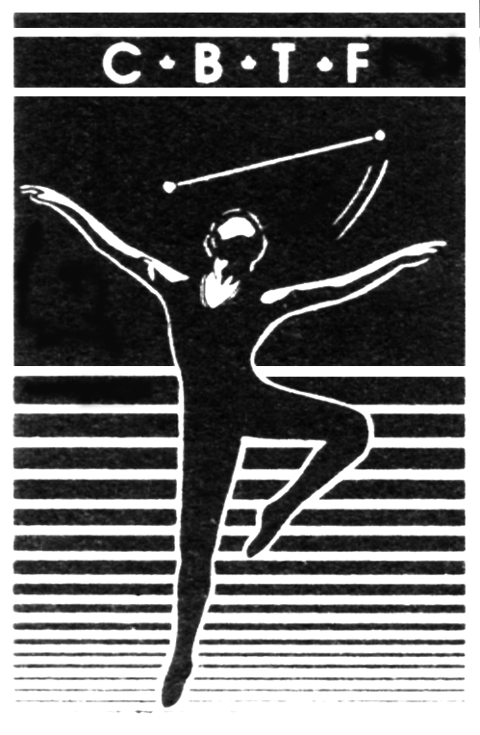
Canadian Baton Twirling Federation

La Fédération Canadienne de Baton Sportif

General Information

Preliminary CBTF Contingent Schedule - Subject to change - schedule will be confirmed after June 15, 2022

CBTF Contingent Schedule - Subject to change
Date
Thursday, July 28 | Canadian Contingent arrives in Turin and checks in at contingent hotel  practice if possible – not mandatory to practice this day
Friday, July 29 | Practice day  Secret Pal starts today  Canadian Contingent Welcome Reception (tentative)
Saturday, July 30 | Practice day
Sunday, July 31 | Music Tests & Practice Sessions
Monday, August 1 | Practice Sessions  Athlete’s Party
Tuesday, August 2 | Practice Sessions  Opening Ceremonies
Wednesday, August 3 | Short Program Competition
Thursday, August 4 | Pair Preliminary Competition  Senior Men and Senior Women Freestyle Preliminary Competition
Friday, August 5 | Youth & Junior Women Freestyle Preliminary Competition  Youth & Junior Men Freestyle Preliminary Competition
Saturday, August 6 | Team Preliminary Competition  Youth & Junior Women Freestyle Semi-Final Competition  Senior Women & Senior Men Freestyle Semi-Final Competition  40th Anniversary Grand Gala Celebration
Sunday, August 7 | Youth & Junior Women’s Freestyle Finals  Youth & Junior Men’s Freestyle Finals  Senior Men & Women’s Freestyle Finals  Youth & Junior Pairs Finals  Senior Pairs Finals  Team Finals  Awards  Closing Ceremonies  Final Secret Pal day

Notes:
- Schedule is subject to change
- Welcome Reception date tentative
- Practice schedule is tentative until confirmed by CBTF – late June
- Transportation to/from practice facilities will be by bus
- Transportation to/from the competition venue will be by bus

Venues

Competition Site:
The competition will be held at the Pala Ruffini, a multi-purpose indoor arena, with a seating capacity of 4,500 spectators.

Average temperature in August is high 20’s and it will be humid.

Contingent Hotel:
Hotel NH Torino Lingotte Congress (Headquarters Hotel), via Nizza 262 – 10126 Turin, https://www.nh-hotels.com/torino/lingotto.
The hotel is located next to a shopping and cinema complex and is just steps away from a range of Italian restaurants as well as the Lingotto metro station.
- 10-minute subway ride to Porta Nuova train station, in Turin’s cosmopolitan center and a 5-minute walk to Piazza San Carlo and Piazza Castello
- Short walk to the Automobile Museum with its collection of nearly 200 cars
- A few steps from Eataly – the international gastronomic center

Power Adaptors for Italy
The best power adapter for Italy will be a Type L plug adapter which is suitable for powering any 230 volt appliance or device. [2] [AD]

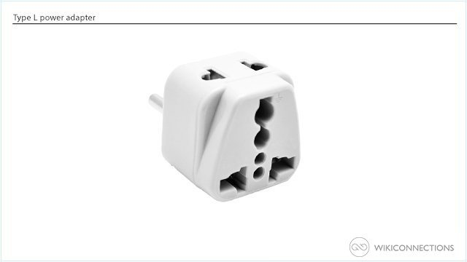 | You will need to pack a Type L plug adapter for Italy if your plug doesn't fit into an Italian power outlet.  The type of power adapter, converter or charger that you'll need to bring when visiting Italy all depends on the voltage and type of device that you're trying to use in an Italian power outlet.  You will need to bring a suitable power adapter to fit a Canadian plug in an Italian power outlet. As the voltage is different in Italy you also need to pack a power converter for Italy if your device isn't dual voltage and check that it can work with a 50hz power outlet.

If your device can run on 230 volts or is dual voltage and your plug will fit in an Italian power outlet then you can use it in Italy without needing a plug adapter.

If you simply want to power one or more USB devices such as a cellphone or a tablet then a USB travel power adapter is suitable and it will work with any voltage, however make sure that you choose one which has a Type L plug adapter otherwise you'll also need to use a suitable plug adapter for Italy.

An increase in use of a cellphone during a vacation will leave you with a flat battery quickly, it is practical to pack a power bank if you need to keep your cellphone battery or other devices charged throughout the day whilst travelling to an unfamiliar country.
ITALY USES THE EURO. Well in advance, you should order Euros. The best way to exchange currency in Italy is to use your debit card at official ATMs after your arrival. However, you may be subjected to some commission and conversion fees. Consider the other options only in cases of necessity. It is recommended you use only ATMs from official and popular banks. Usually, they are available in the center of the town and large airports such as Fiumicino. Never use private ATMs if it isn’t an emergency. They will charge a lot more fees than average in most situations. You should avoid using ATMs at night, even if they have security cameras.

This package is designed for the World Championship athlete, coach, and chaperone.

Also note - breakfast and dinner are included with the daily price of your hotel room. Athletes and coaches will order the set lunch buffet at the venue if it is available. We will update once further details are released.

The package components are:
- Accommodation at the Canadian Contingent Hotel
- Team Canada Welcome Reception
- 2022 World Championship spectator tickets
- 2022 World Championship program
- Transportation

1. Getting to the World Championships

CBTF may arrange for a group departure from Toronto, depending on flights and costs. We hope to have this information available at the contingent meeting following Team Trials. The contingent charter bus will be co-ordinated once flight plans are known.

All coaches, judges, officials, and athletes must arrive in Turin by July 28th, and must remain until the end of the World Championship closing ceremony and awards. Parents and other spectators may arrive at any time, bearing in mind the Opening Ceremony for World Championships is scheduled for the evening of Tuesday, August 2nd.

2. At the World Championships

Upon arrival at the hotel, the hotel may require a credit card for any incidental charges associated with your room. Your room is not guaranteed until check-in– early check-in is not guaranteed. When staying at the hotel chosen for the contingent, as part of the contingent, do not expect to pay the same price as an online advertised price. The group bookings carry different costs.

Please note that a city tax of 3.70 euros per person per night is not included in the rate and must be paid by each traveler at the hotel.

A Breakfast Buffet and Dinner is included at the hotel. Lunches will be pre-arranged for practice days. Bring an insulated lunch bag and water bottle with you. After the Closing Ceremony on August 7, the final Secret Pal gifts will be exchanged with the rest of the evening free for everyone to enjoy in their own fashion.

The Canadian Contingent Welcome Reception will be held on July 29th (date tentative). This event is mandatory for athletes, coaches and officials but is open to all members of the Contingent – especially friends and family. In fact, this Welcome Reception is a special occasion to show our support for all of the athletes that are representing Canada at the World Championships – everyone is encouraged to attend.

The Shuttle bus provides regular transportation between the hotels and the venue. We are not within walking distance. A taxi may not be possible. We will schedule circuits to get everyone where they need to be on time. The cost of transportation is included in the athlete and coach fee.

Official World Championship Programs are available for pre-purchase – supplies may be limited or unavailable at the competition itself. Interested Spectators can choose to pre-purchase their own Program by selecting this option. All Athletes, Officials and Coaches will receive a Program Book with their credentials package.

As in previous years, an International Twirl Nations Clinic will be held in conjunction with the competition. Attendance is strongly recommended. Skipping out on the clinic is discouraged by CBTF. An outstanding line-up of clinicians is being secured. Coaches and Athletes will be registered for the Twirl Nations Clinic and the cost is included in the athlete and coach fee. More information to come soon!

3. Completing the Forms

The Contingent Package consists of two forms:
- Traveler Payment Form – Each contingent traveler, adult or child, must complete this Traveler Payment Form
- Hotel Worksheet – Each group of travelers staying together should complete a single Hotel Room Worksheet. This Worksheet is used to calculate the ‘per person’ hotel cost, which is transferred to the Traveler Payment Form. Please note that the hotel rooms have two twin beds.

After May 23, 2022, you are financially responsible for all components selected in your package. Changes to the selections made on these forms can only be accepted on a best-efforts basis. In the event of a cancellation, for any reason, CBTF will make every effort to obtain refunds, but in many cases this will not be possible – the host country has established end-of-May commitment dates for most products and services.

All payment amounts on these forms are estimates. CBTF purchases the products and services in advance on behalf of all travelers and then applies the money received from the travelers. Due to the uncertainties caused by COVID and fluctuation in costs, you may be required to pay additional costs once we return from Italy and all charges have been incurred and converted to Canadian Dollars.

The completed Traveler Payment Form and Hotel Room Worksheet can be handed directly to Sue Mepham during Contingent Meeting in Regina. All forms are due no later than May 23, 2022.

All forms, and the initial deposit, will be collected at the Team Trials. If you are not travelling with your child to the Team Trials the forms can be emailed to Sue Mepham at: office@cbtf.ca and the deposit etransferred to Terry Stewart at: treasurer@cbtf.ca. Your etransfer password must be: Italy

All payments should be made payable to “CBTF Inc.”. Please clearly indicate the traveler’s name on each payment.
Traveler Payment Form
Each contingent traveler, adult or child, must complete the Package Payment Form. The Package Payment Form is used to calculate the per traveler cost of the package and it defines the schedule of payments. Optional package components such as Team Canada Welcome Event, extra programs and fan shirts can be selected on a per traveler basis.

Registration Information
- Name and contact information for each traveler
- Per Person Hotel Cost
  - Complete the Hotel Worksheet to calculate the Per Person Hotel Cost
- Canadian Contingent Welcome Reception
  - Required for Athletes, Coaches and Officials
  - Optional for Family/Friends, but strongly encouraged
- Transportation Package
  - Local transit between hotel and competition venue
  - Already included for Athletes, Coaches and Officials
- Official Event Programs
  - Already included for Athletes, Coaches and Officials
  - Optional for Spectators/Fans
- Athlete Fee
  - Mandatory for all Athletes, includes:
    - Practice Gym Rental
    - Official Program
    - Cost-share for Team Manager(s) and 2nd Judge
    - Badges
- Coach/Officials Fee
  - Mandatory for all Coaches and Officials, includes:
    - Official Program
    - Badges

You must notify the contingent coordinator AND the Team Manager if you have any food allergies or meal restrictions. We do not know what you do not tell us. Please send the information to Sue Mepham at office@cbtf.ca. This applies to athletes, coaches, and parents.

Hotel Worksheet
Complete one Hotel Room Worksheet per room. The form does not have to be duplicated for each guest – simply copy the ‘Per Person Hotel Cost’ calculated at the bottom of the page to each guest’s Payment Form.

Remember that the rooms can easily accommodate 1 or 2 guests.

Enter the names of your roommate and select the appropriate rate for your occupancy – Single, Double.

Divide the Total Hotel Cost by the Occupancy to determine the Per Person Hotel Cost. The Per Person Hotel Cost is copied to each Traveler’s Payment Form.
Complete one Package Payment Form per traveler (adult or child).

Registration Information (one person per form)

Circle One: | Athlete | Coach | Official | Chaperone | Spectator

Name:
Address:
City: |  | Province: |  |  |  |  | Postal Code:
Phone:
 | (Cell)
Email:

Price Calculator
o | Per Person Hotel Cost (complete hotel worksheet) | $___________________  From Hotel Room Worksheet
o | Canadian Contingent Welcome Reception | $___________________  Enter $60 if selected
o | Transportation Package – Hotel/Competition Venue | $___________________  Enter $250 if selected
o | Official World Championship Program | $___________________  Enter $25 if selected
o | Athlete Fee (mandatory), includes shared costs, team wear, transportation, welcome reception, program and clinic | $___________________  Enter $1,250 if selected
o | World Championship Tickets  Adult 5 day ______ x $145  Child (6-11) 5 day _____ x115 | $___________________  Enter total cost
o | Coach/Officials Fee (mandatory), includes team wear, transportation, welcome reception, coach’s badge, program and clinic | $___________________  Enter $525 if selected
o | Fan Shirt (M or F) (Size: ______) | $___________________  Enter $30 if selected
o | Entry Fees:  Freestyle: _______ x $ 70  Pair Fee: _______ x $ 70 each  Team Fee: _______ x $ 70 each | $___________________  Enter total fees
o | Athlete/coach buffet lunches at competition | $___________________  Enter $ if selected

GRAND TOTAL
Payment Schedule
Initial Deposit | Due May 23, 2022 | $1,000.00
Final Payment | Due June 15, 2022
** DUE TO COVID AND CONTINGENCIES, UNKNOWN, ETC. THERE WILL LIKELY BE A FINAL INVOICE AFTER THE COMPETITION

Complete one Hotel Room Worksheet per room.

Transfer the Per Person Hotel Cost calculated below to the Hotel line of each person’s Price Calculator (on the previous page).

At this time we have only booked rooms with double occupancy – 2 twin beds. We cannot guarantee any single occupancy rooms or triple occupancy rooms, but can make best efforts to secure such a room if requested.

Room Reservation Request

Roommate 1:

Roommate 2:

o | Base Hotel (11 nights – July 28 – Aug 8, 2022) | $___________________  Enter $ 2,960 if selected

o | Extension Nights  Extension Nights: August 8 August 9  Choose Daily Rate (same room size and occupancy as base)  o $270 per night

Calculate Extension cost:

___________ x _________ = $___________________
# days $270

Total Hotel Cost $

Per Person Hotel Cost
(Divide Total Hotel Cost by number of people in the room) $
Copy this amount to the Hotel line
Of each traveler’s Price Calculator
(on the previous page)

