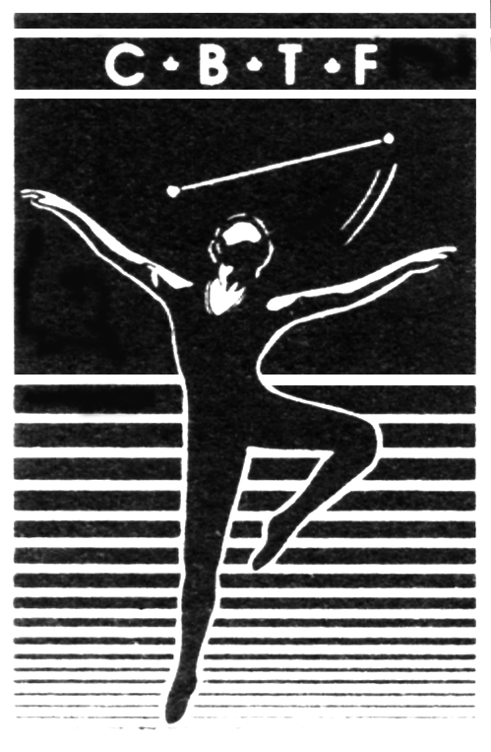
Canadian Baton Twirling Federation

La Fédération Canadienne de Baton Sportif

Canadian International Cup Athletes will participate in the Team Canada Secret Pal Exchange! It will be your job to make sure that your Secret Pal receives little gifts, notes, cards, positive phrases, pictures etc. that will make them feel happy, motivated and part of the team.

DO NOT SPEND A LOT OF MONEY. Be creative and make your own gifts and cards but make sure your secret pal can’t figure out who you are!

- Have someone else deliver your Secret Pal gifts.
- Be secretive, mysterious, sly and creative!
- Have fun, help support and motivate your teammates.

You will give your Secret Pal something on each practice and competition day that we are in Italy for the World Championship (July 29 through August 7). You need 10 gifts in total.

You may spend $1 - $5 on the 9 daily gifts (July 29 – August 6). On the final day – Sunday, August 7 we will gather together and try to guess who your Secret Pal is. At this time you will exchange your final gift ($15 - $20).

More information will follow, along with the location of the final exchange.

DO NOT TELL ANYONE WHO YOUR SECRET PAL IS!

HAVE FUN!

Name
Age |  | Birthdate |  | Zodiac Sign

What are your FAVOURITES…

Color
Flavoured Water
Hard Candy
Fruit or Vegetable
Jewelry
Animal
Hair Product
Game
Author
Food Gift Card
Sports Team
Chocolate Bar
Gum or Mints
Holiday
Bath and Body Works Scents
Starbucks or Tim Horton’s or Both?
What are your SIZES? T-Shirt Shoes
I like to collect
One thing I would like from Italy is
I do not need any more of these things, thanks:

***Did you know Pastiglie Leone is the most famous original candies of Turin. Tiny pastel colored drops of sugar available in over 40 different flavors. The tin boxes with art nouveau and liberty designs are collectors’ items and are perfect for personalized souvenirs or gifts.  Do you think you might like your Secret Pal to find you your very own Pastiglie Leone from Italy? | 