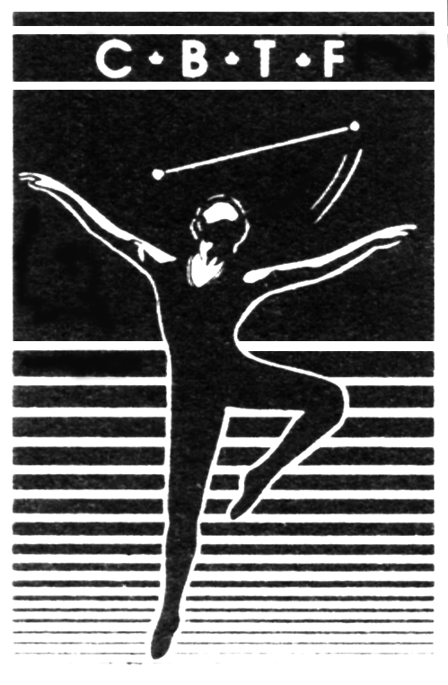
Canadian Baton Twirling Federation
La Fédération Canadienne de Baton Sportif

La Fédération Canadienne de Baton Sportif

PILOT PROJECT REPORTING TEMPLATE
Please submit this report to the CBTF Technical Chair (technicalchair@cbtf.ca) no later than July 1st.
Province:
Name of Pilot Project | Level B Short Program
Name of Project Lead:

- Scope of the Pilot Project:
Number of participating clubs:
Number of participating athletes:
Number of participating coaches:
Number of competitions/events that pilot project was tested at:

- Member Feedback:
Through the use of structured survey (paper or email) get feedback from people who participated in this pilot project (example: athletes, coaches, judges, parents, competition directors). Answers to the following types of questions will be helpful:
-what worked well?
-what didn’t work well?
-what did you like about the project?
-what did you dislike about the project?
-are there areas that are lacking information and need improvement?
-what, if any, other “tools” would you like to see from CBTF if this project were to be fully implemented?
-other feedback

- Lessons Learned:
(Describe what you, as the person running the pilot project in your province, would do differently next time. What worked well? What didn’t work so well? Was there a cost implication?)

- Conclusions
(Given the choice, would your province recommend that this pilot project become standard policy for the CBTF? Answer “Yes” or” No” and provide a reason “why”.)

